|  |  |
| --- | --- |
| **Key Vocabulary** | |
| **Angles** | Tribes from an area today known as modern day Denmark that settled in Britain from around AD 450. They were one of  the tribes that became known as the first Anglo-Saxons. |
| **Saxons** | A tribe from the north coast of Europe, especially Germany, that settled in Britain from around AD 450. They were one of the tribes that became known as the first Anglo-Saxons. |
| **Picts** | Tribes originally from Scotland who were often feared. |
| **Scots** | People from Ireland who, like the **Picts**, were fierce and powerful fighters. |
| **invaders** | People who enter an area and take control of it by force. |
| **kingdom** | An area ruled by a king or queen. |
| **Pagan** | Someone who follows the **Paganism** religion and worships many gods and goddesses. |
| **Christianity** | A religion based on the teachings of Jesus Christ. |

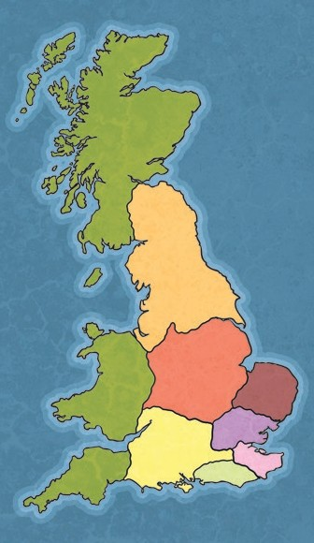

By c. AD 410, the last of the Romans had left Britain. This made Britain vulnerable to invasion. The warriors that **invaded** became known as the first Anglo-Saxons. Most of Britain was divided into seven Anglo-

Saxon **kingdoms**.

The **Picts** and **Scots** were a constant threat without Roman support.

**Northumbria Mercia**

**East Anglia Wessex Essex**

**Kent**

**Sussex**

**Anglo-Saxon Kingdoms**

**1**

**2**

**3**

**4**

**5**

**7**

**6**

**The Romans Leave Britain**

**7**

**6**

**5**

**4**

**3**

**2**

**1**



**3500 BC**

**AD 1500**

Maya Civilisation

**AD 1**

Stone Age

Bronze Age

Iron Age

Roman Britain

Anglo- Saxon Britain

Ancient Egypt

The Romans preferred living in towns but the Anglo-Saxons preferred to live in small villages.

Anglo-Saxon influence can be seen in place names in Britain today. Wessex was a place named after the West **Saxons** who settled there. Sussex was named after the South **Saxons**.

The **kingdom** of Mercia (which means border people) was named Mercia because it had so many borders with other **kingdoms**.

**Living in Anglo-**

**Saxon Britain**

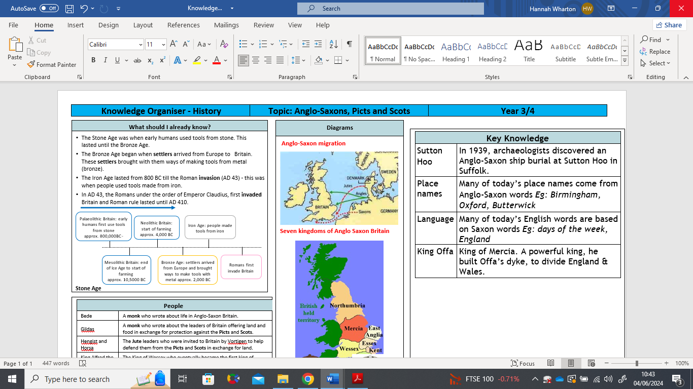

At the end of this period, **Christianity**

became the main religion in Britain.

In AD 597, a Roman monk called Augustine was sent to tell the Anglo- Saxons about **Christianity**.

King Ethelbert of Kent was the first to be converted and was baptised along with 10,000 of his people.

Over the next 100 years, the rest of the kingdoms converted to **Christianity** too.

**The Anglo-Saxons and Christianity**

Many **Christian** places of worship were built at this time.

Canterbury Cathedral was founded by Augustine. It was rebuilt from AD 1070 after a fire.

A monastery was built on the island of Lindisfarne. This Holy Island was very influential and the monks here were successful at spreading **Christianity** across the north of England.

**Christian Places of Worship**

|  |  |
| --- | --- |
| **Key Figures in Anglo-Saxon Britain** | |
| **King Vortigern** | The king left in charge after the Romans left Britain. |
| **Hengest and Horsa** | King Vortigern’s brothers from Jutland (in modern day  Denmark). They helped to keep the  **Picts** and **Scots** out of Britain. |
| **Augustine** | A Roman monk who was sent to Britain to persuade the Britons to become **Christians**. After his death, he was made a saint. |
| **King Ethelbert** | The king of Kent who was the first King to convert to **Christianity**. |
| **Columba** | An Irish abbot (head of a monastery) who introduced **Christianity** to Scotland. |
| **King Oswald** | The king of Northumbria who introduced **Christianity** to his people. |
| **Aidan** | An Irish monk who helped King Oswald introduce **Christianity** in Northumbria. He became the first bishop of Lindisfarne. |

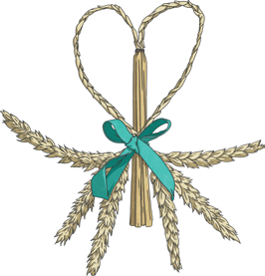

The religion of the early Anglo-Saxons was **Paganism**. They worshipped many gods. Festivals and sacrifices were made to the gods and goddesses.

**Pagans** also believed in good and bad omens, lucky charms, spells and magic.

They would perform many rituals that they believed would protect them in this life and the next.

**Anglo-Saxon Paganism**